Your First Prompt
You talk to Claude Code like you would any AI assistant. Here are a few things to consider that can both protect you and make things easier.
Auto-accept vs. approval · Plan Mode · A worked example · Recap
ON THIS PAGE
› 1. Auto-Accept vs. Approval
› 2. Plan Mode
› 3. Example: Add a Dark Mode Toggle
› 4. Recap

01 Auto-Accept vs. Approval
You can choose whether Claude auto-accepts every file change it suggests, or whether it asks for your explicit permission each time. Press Shift + Tab to cycle between modes.
Mode | What happens
Approval mode | Claude asks permission each time it wants to edit a file or run a command.
Auto-accept mode | File edits are approved automatically, but commands still require your permission.

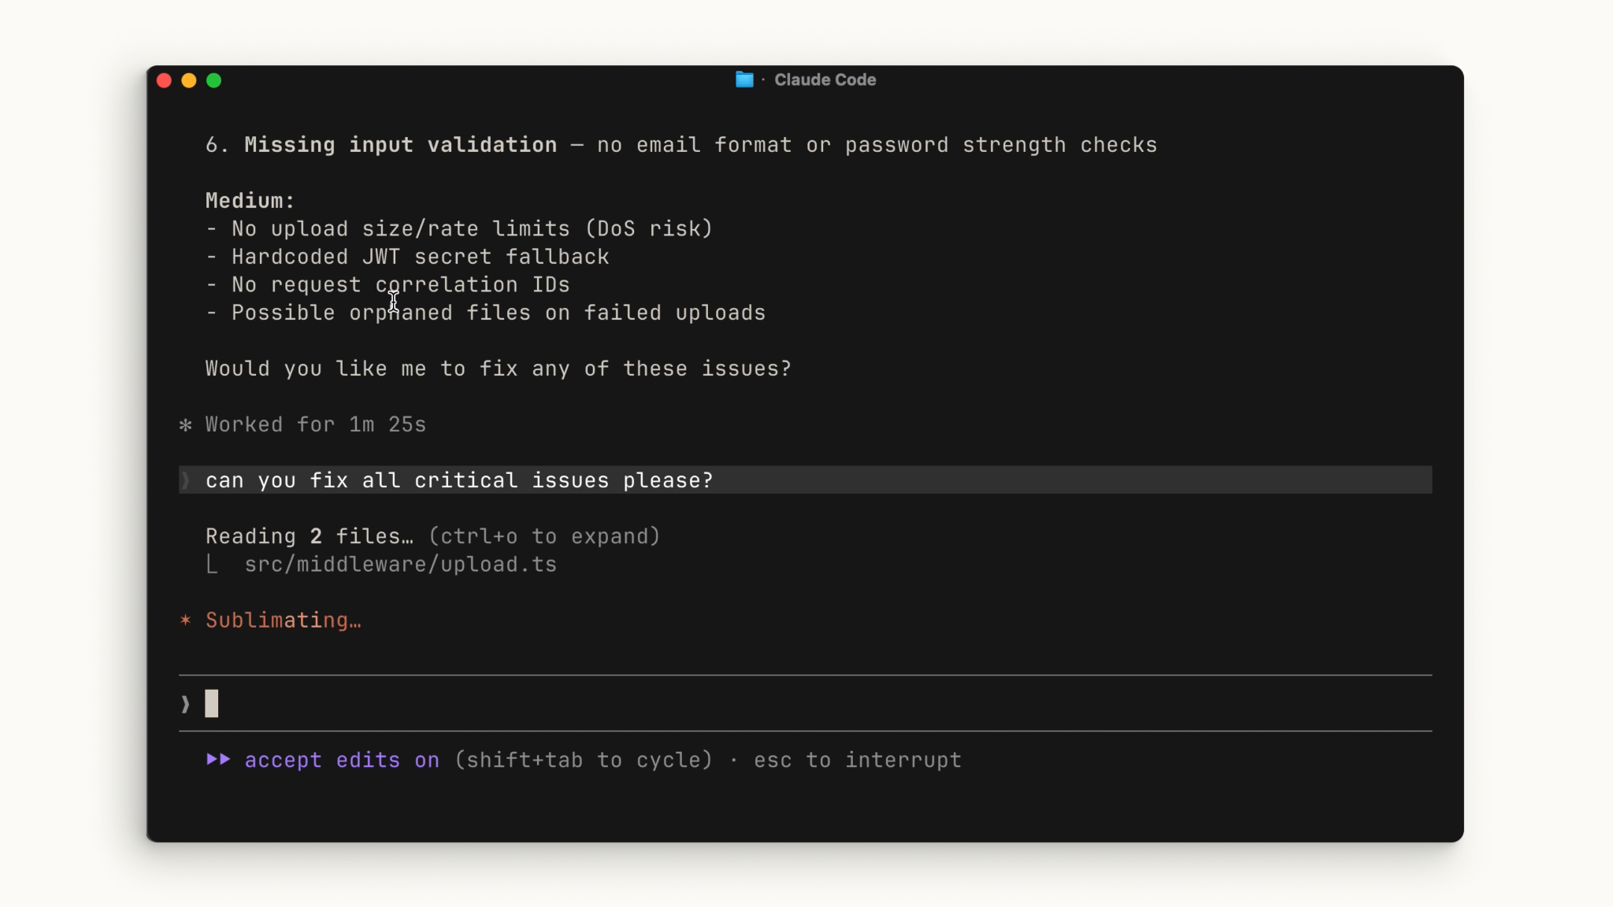
In auto-accept mode, the footer reads “accept edits on” - file edits apply automatically.
NO WRONG ANSWER
There’s no right or wrong choice here - use whichever mode you’re most comfortable with.

02 Plan Mode
Within the Shift + Tab menu is Plan Mode. Plan Mode takes your prompt and uses read-only tools to analyze your codebase and research your suggested implementation. It asks clarifying questions along the way, then returns a detailed plan it can execute.
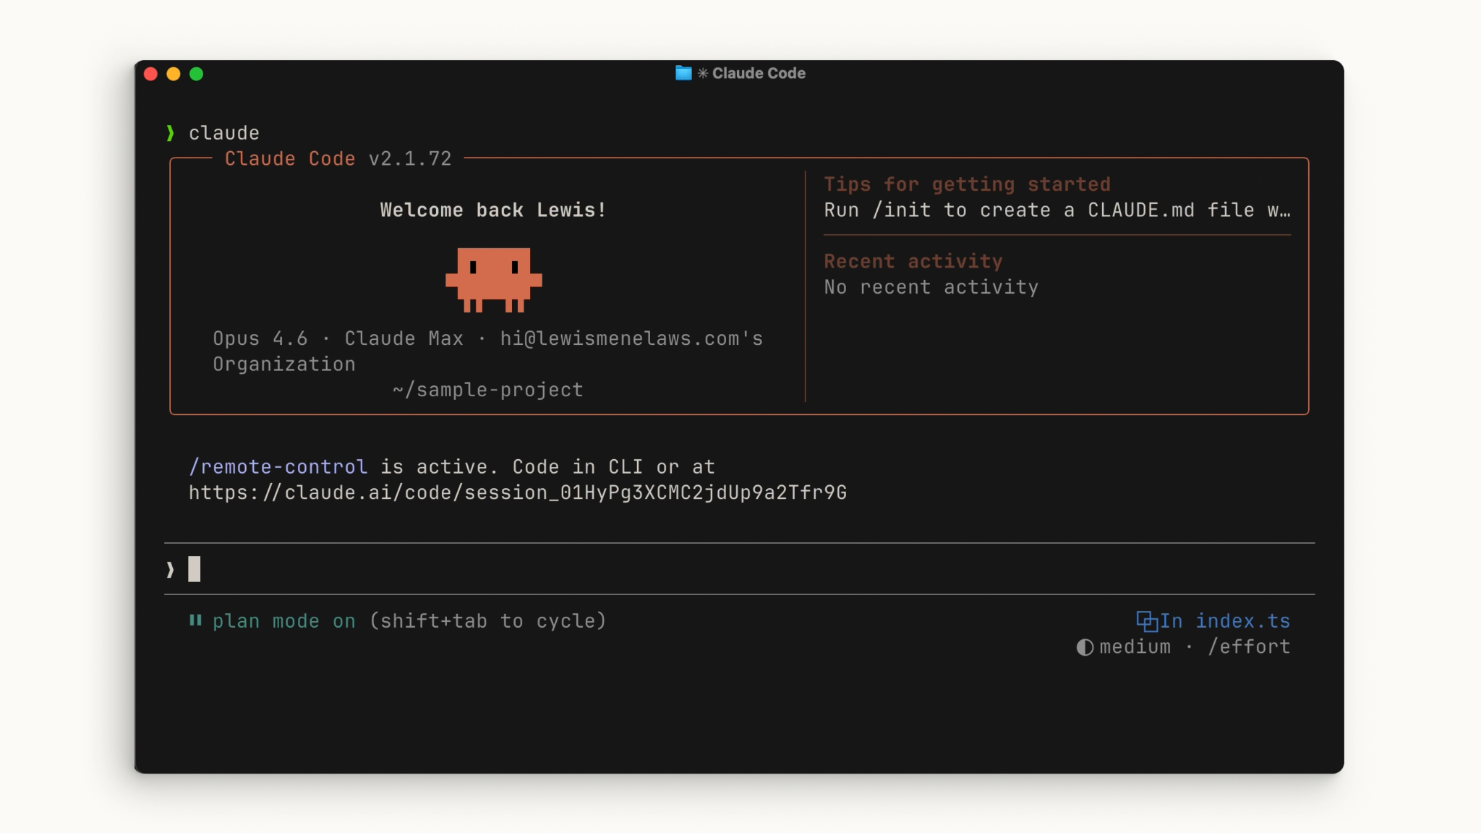
When Plan Mode is active, the footer reads “plan mode on.”
WHEN TO REACH FOR PLAN MODE
Plan Mode shines for complex, multi-step changes - or for a safe, read-only code review before any code is touched.

03 Example: Add a Dark Mode Toggle
Let’s walk through an example. Say you have an application that needs a dark mode toggle. Open the root directory of your project and run claude, then press Shift + Tab a couple of times to enter Plan Mode and write a prompt like:
You can clone the demo project from the link below and run it locally: Demo Files
TRY A PROMPT LIKE THIS
› My app needs a dark mode implemented across the entire app. Can you create a toggle switch on the header that allows a user to toggle between light mode and dark mode? I need you to find a good contrast color that works based on my existing light theme.
OR
My app needs a dark mode implemented across the entire application.

Requirements:
- Add a dark mode toggle switch in the header.
- The toggle should persist the user's preference using localStorage.
- Use CSS variables instead of duplicating styles.
- Find accessible contrast colors that work well with the existing light theme.
- Ensure all sections (hero, features, testimonials, pricing, footer, buttons, cards, navigation, and links) support dark mode.
- Add smooth transitions between themes.
- Update the README with a brief explanation of how the dark mode implementation works.

Before making changes, analyze the existing styling approach and provide a short implementation plan.

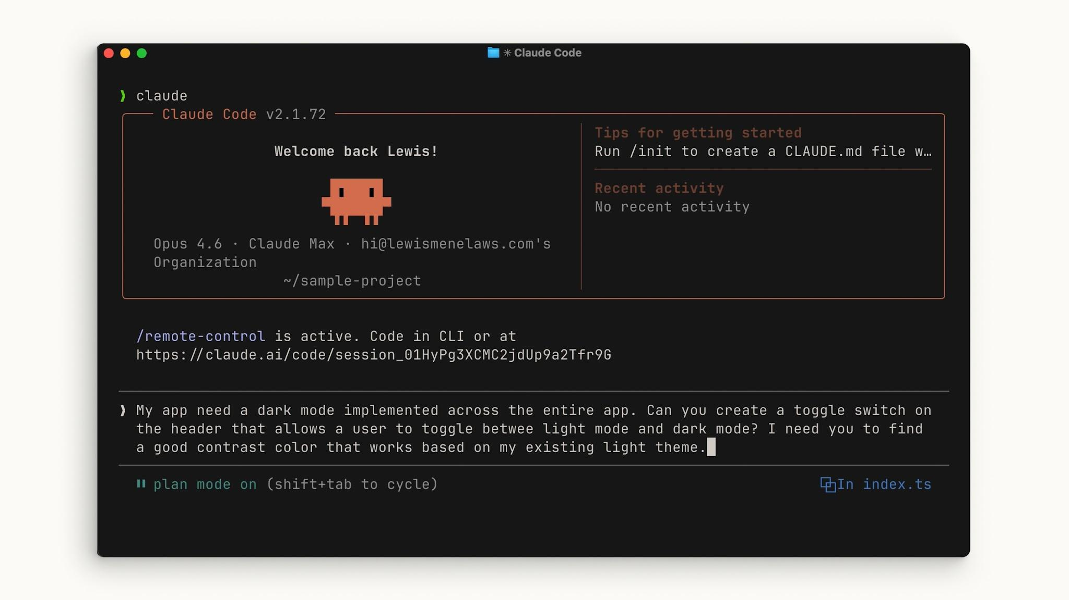
Entering the prompt in Plan Mode - the footer confirms “plan mode on.”
Let Claude plan it out. After reviewing the plan, if it looks good, accept it and let Claude ask you for approval at each step. At the end, you can see exactly what Claude did and how it reached its conclusions.

04 Recap
When using Claude Code, try to be as descriptive as possible with your prompt. A little extra context up front gives Claude a much better shot at the result you want.
KEY TAKEAWAYS
- Be as descriptive as possible with your prompt.
- Want to stay in the loop at every step? You can - approval mode keeps you in control.
- Use Plan Mode to let Claude dig into the details of what you want before executing any code.

Be descriptive, stay in control, and let Plan Mode do the thinking first.

